Experiment 7

Student Name: Nikhil Kumar UID: 25MCI10036
Branch: MCA (AI/ML) Section/Group: 25MAM-1(A)
Semester: 2-SEM Date of Performance: 31/03/2026
Subject Name: Technical Training - 1 Subject Code: 25CAP-652

- Aim of the Session:

Implementation of joins in PostgreSQL (inner join, left join, right join, self-join and cross join)

- Software Requirements:
- PostgreSQL
- pgAdmin
- Windows Operating System

- Objectives of the Session:

Apply joins to a real-world database schema (e.g., Students, Courses, Enrollments, Departments)

- Theory:

A JOIN in SQL is used to combine rows from two or more tables based on a related column between them. Joins are essential in relational databases because data is often stored in multiple tables to reduce redundancy and improve organization.

Types of Joins Used in this Experiment:
- INNER JOIN: Returns only the matching records from both tables.
- LEFT JOIN: Returns all records from the left table and the matching records from the right table. If no match is found, NULL values are returned for the right table columns.
- RIGHT JOIN: Returns all records from the right table and the matching records from the left table. If no match is found, NULL values are returned for the left table columns.
- SELF JOIN: A table is joined with itself to represent relationships within the same table, such as mentor-student or manager-employee relationships.
- CROSS JOIN: Returns the Cartesian product of two tables, i.e., all possible combinations of rows from both tables.
- Practical / Experiment Steps:

Step 0: Creating sample tables and inserting records

Code:

Create table students(

stud_id int primary key,

name varchar(50),

dept_id int

);

create table courses(

course_id int primary key,

course_name varchar(50)

);

create table enrollments(

stud_id int,

course_id int,

primary key(stud_id, course_id),

foreign key(stud_id) references students(stud_id),

foreign key(course_id) references courses(course_id)

);

create table departments(

dept_id int primary key,

dept_name varchar(50)

);

insert into students values

(1,'Nikhil',101),

(2,'Aman',102),

(3,'Riya',101),

(4,'Sanya',103),

(5,'Rahul',Null);

insert into courses values

(201,'DBMS'),

(202,'OS'),

(203,'CN'),

(204,'AI');

insert into enrollments values

(1,201),

(1,202),

(2,201),

(3,203);

insert into departments values

(101,'Computer science'),

(102,'Electronics'),

(103,'Mechanical');

Step 1: List all students with their enrolled courses (INNER JOIN).

Code:

select s.name,c.course_name

from students s

inner join enrollments e on s.stud_id=e.stud_id

inner join courses c on e.course_id=c.course_id;

Output:

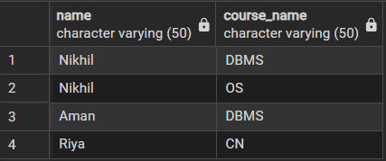

Step 2: Find students not enrolled in any course (LEFT JOIN).

Code:

select s.name from students s

left join enrollments e on s.stud_id=e.stud_id

where e.stud_id is Null;

Output:

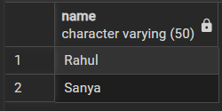

Step 3: Display all courses with or without enrolled students (RIGHT JOIN).

Code:

select c.course_name,s.name

from students s

right join enrollments e on s.stud_id=e.stud_id

right join courses c on e.course_id=c.course_id;

Output:

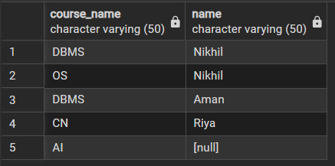

Step 4: Show students with department info using SELF JOIN or multiple joins.

Code:

select s.name,d.dept_name

from students s

left join departments d

on s.dept_id=d.dept_id;

Output:

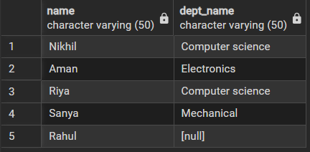

Step 5: Display all possible student-course combinations (CROSS JOIN).

Code:

select s.name,c.course_name

from students s

cross join courses c;

Output:

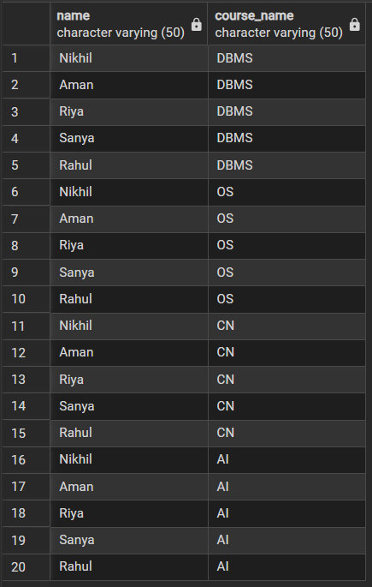

- Learning Outcomes (What I have learned):
- Join Understanding: I learned how to use different types of SQL joins to retrieve related data from multiple tables.
- Practical Database Skills: I understood how real-world schemas such as Students, Courses, Enrollments, and Departments are related in a relational database.
- Data Analysis Ability: I learned how to identify matching and non-matching records using INNER JOIN, LEFT JOIN, and RIGHT JOIN.
- Advanced SQL Usage: I understood the use of SELF JOIN for hierarchical relationships and CROSS JOIN for generating all possible combinations.

